# Ddfasafdsa

Fdasfdsa

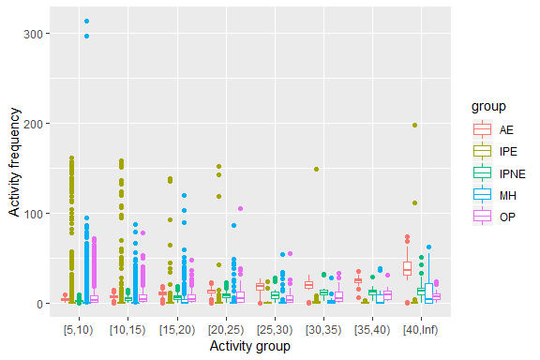

Fdasfd

|  |  |
| --- | --- |
|  |  |
|  |  |

Fdsafdsa